**Submission Instructions:**

Your submission for this assignment should be a Word document that includes the following screenshots, each labeled for the step that the screenshot represents:

**Part 1: Writing Data to an Excel File**

1. Provide a screenshot to show that you successfully created the two folders: input and output.

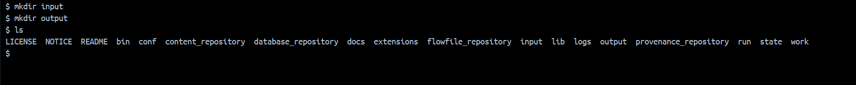

1. Provide a screenshot to show that you successfully copied the movies.xlsx file in the input folder.



1. Provide a screenshot to show that you successfully created the Assignment17 process group.

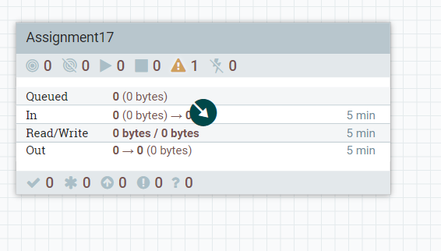

1. Provide a screenshot to show that you correctly configured the *properties* for the GetFile *processor*.

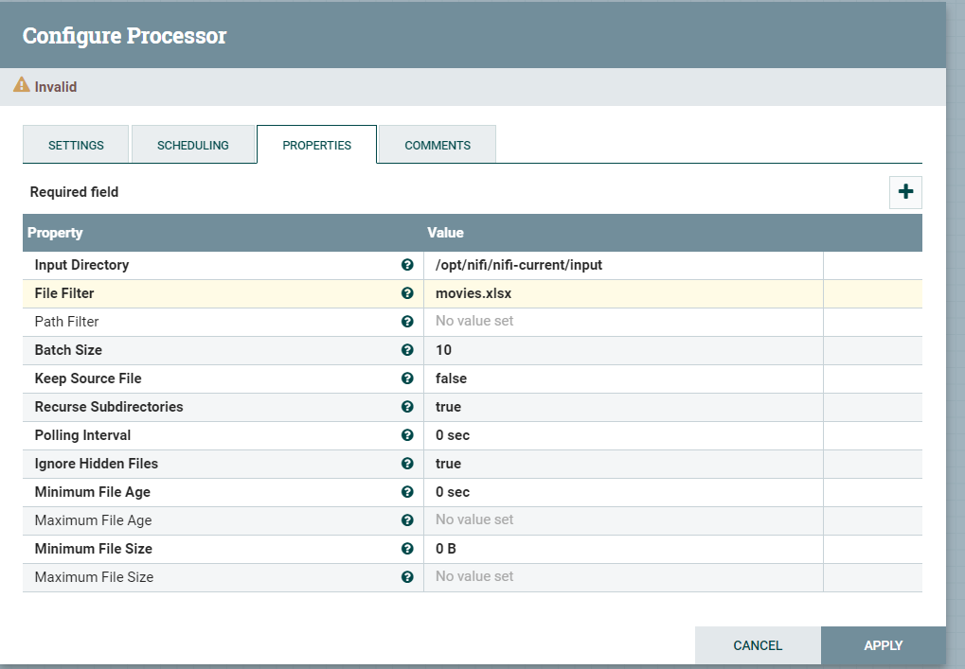

1. Provide a screenshot to show that you correctly configured the *properties* for the ConvertExcelToCSVProcessor *processor*.

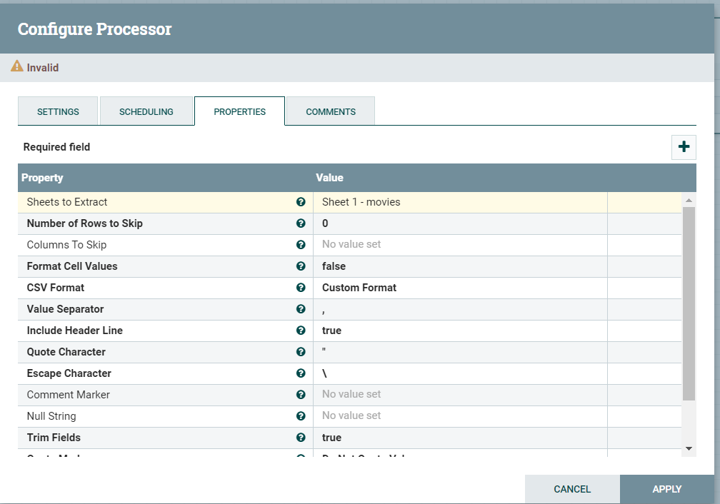

1. Provide a screenshot to show that you correctly configured the *properties* for the PutFile *processor*.

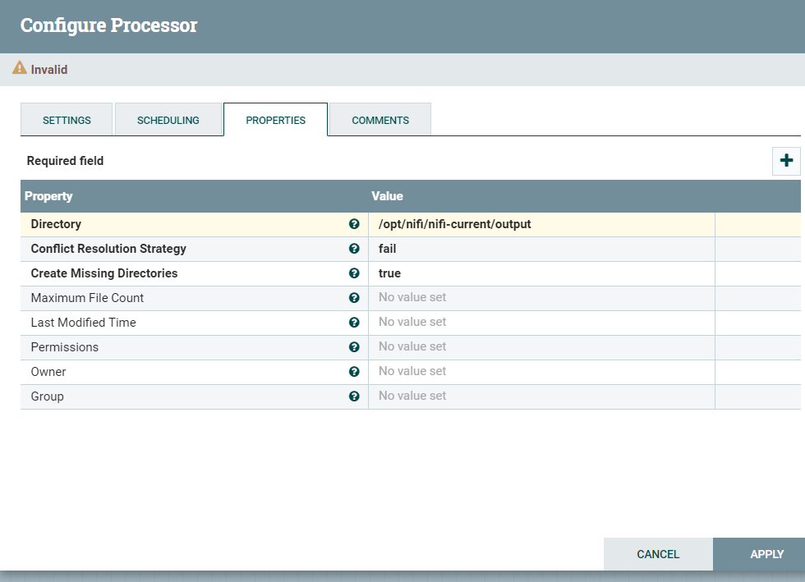

1. Provide a screenshot to show that you successfully connected all the *processors* with the correct relationships.

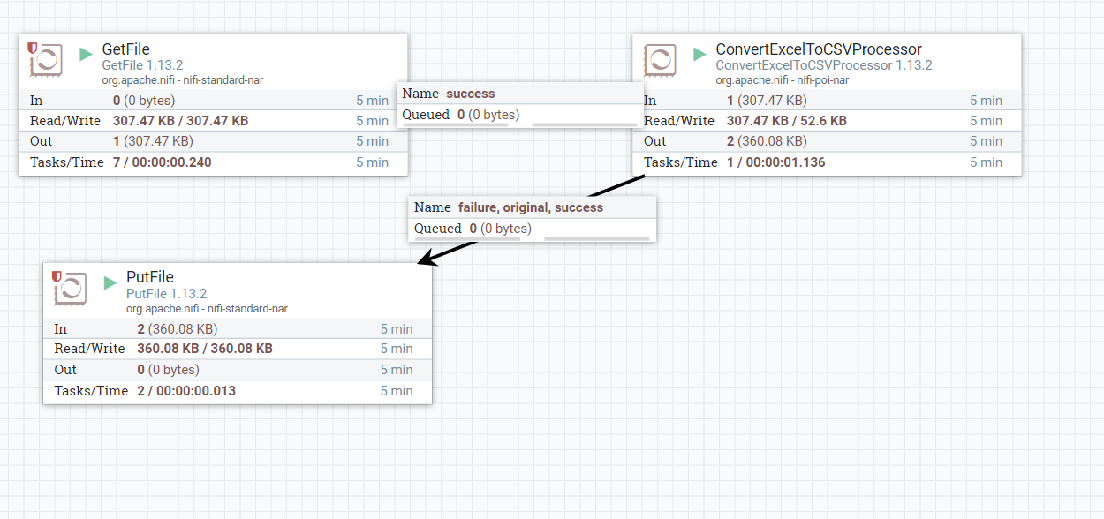

1. Provide a screenshot to show that all the *processors* are running (as indicated by a green arrow).



1. Provide a screenshot to show that the movies_Assignment.csv file has been created.

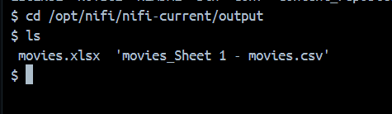

**Part 2: Writing Data to an SQL Database**

1. Provide a screenshot of your MySQL Workbench to show that you have successfully initialized an empty movies table in the movielens database.

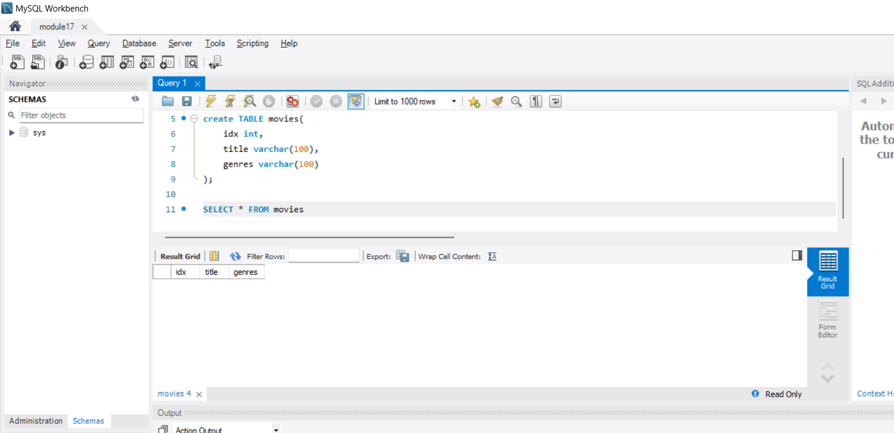

1. Provide a screenshot to show that the movies.csv file is now on the NiFi *server*.

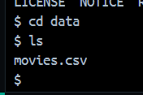

1. Provide a screenshot to show that you successfully opened the NiFi UI.

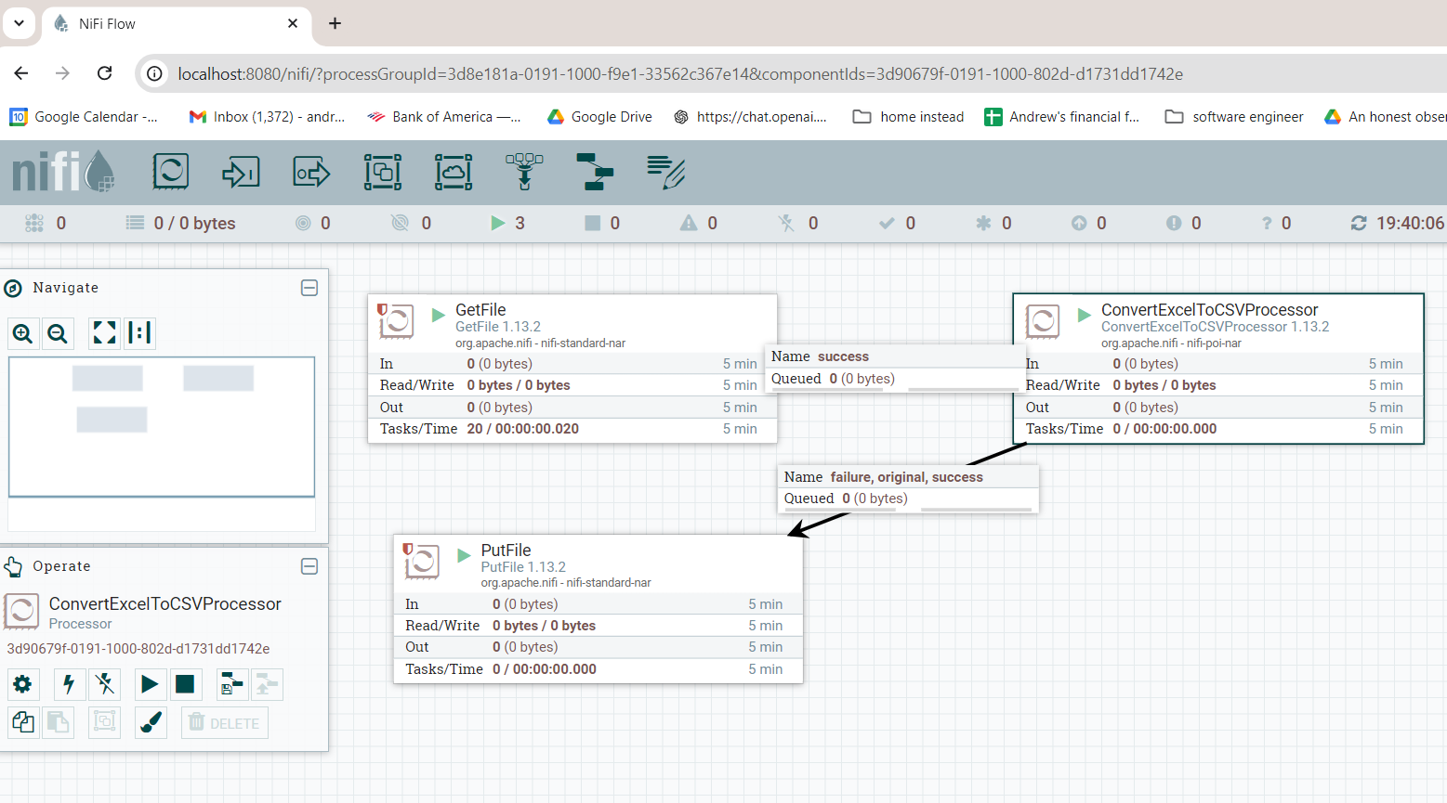

1. Provide a screenshot to show that you successfully created and enabled the MySQL *controller* service.

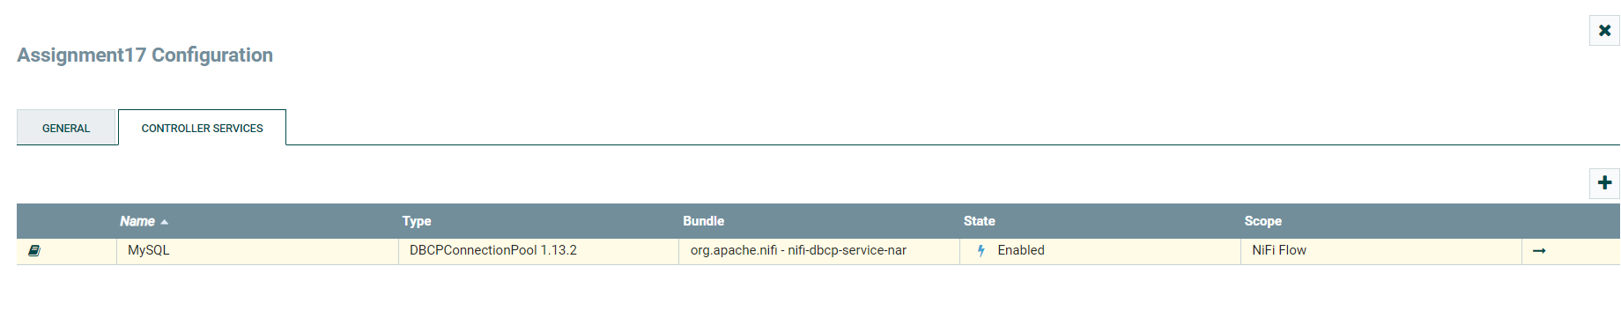

1. Provide a screenshot of the *controller* screen to show that the three *controller* services (*reader*, *writer*, and MySQL) are enabled.

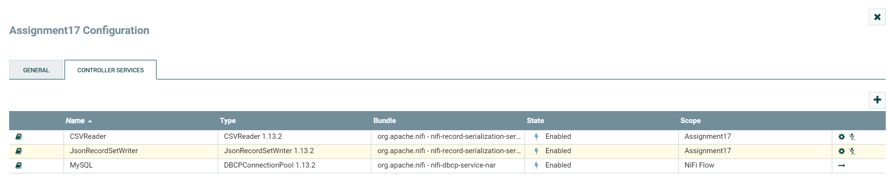

1. Provide a screenshot of your complete data pipeline, including all five *processors*: GetFile, SplitText, ConvertRecord, ConvertJSONToSQL, and PutSQL.

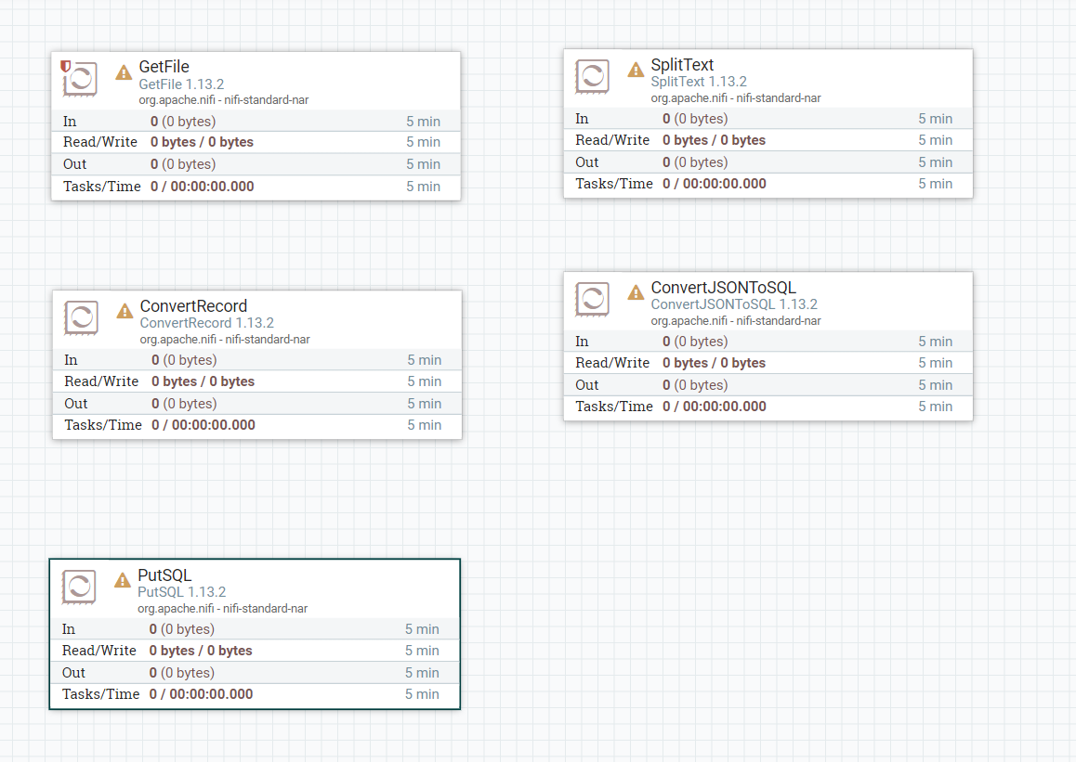

1. Provide a screenshot of all five *processors* to show that the correct *connectors* have been added between the *processors*.

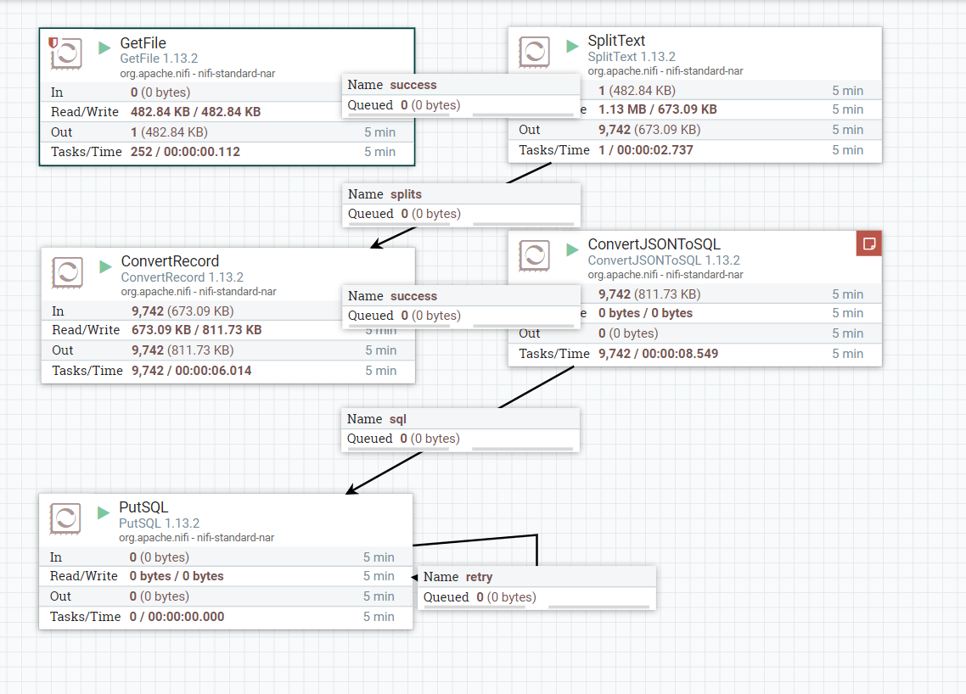

1. Provide a screenshot of your NiFi browser screen to show all five *processors* connected and running.



1. Provide a screenshot of the result of this *query* to show that the movies table in the movieslens database is now saturated with data.

